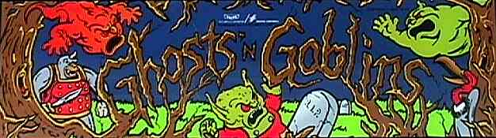

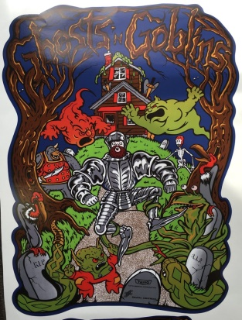**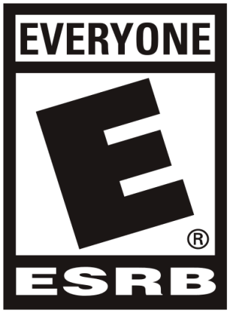Ghosts N Goblins (Makaimura)**

Created by: Tokuro Fujiwara

For: Arcade Machines

Age of Target Players: 10+

Release Date: September 19 1985

Manufacturer: Capcom

Genre: Scroll Fighting

**Table of Contents**

1. Game Outline ----------------------------------------------------------------------- pg.1
2. Characters --------------------------------------------------------------------------- pg.1-2
3. Character Controls ---------------------------------------------------------------- pg.2
4. Game Play --------------------------------------------------------------------------- pg.3
5. Game World ------------------------------------------------------------------------ pg.3-5
6. Music --------------------------------------------------------------------------------- pg.5
7. Game Experience ------------------------------------------------------------------ pg.6
8. Flow Chart --------------------------------------------------------------------------- pg.6
9. Game Mechanics ------------------------------------------------------------------- pg.7
10. Enemies and Bosses --------------------------------------------------------------- pg.7-9
11. Monetization ------------------------------------------------------------------------ pg.9

**Game Outline**

You as the player must hack and slash your way through hordes of the undead to eventually win back your princess. You will use weapons armor and magic’s to make your way through the undead. You will jump and maneuver around obstacles that will thwart your path in this side scroller adventure. Your Health and Magic are represented by the armor your character wears. There are hidden chests throughout the game which allow your character to gain access to better armor and items. You have limited number of lives and must face a boss after each level to progress. You will find treasure chests hidden throughout the levels. To win you must finish the game at least once, but in doing so it opens up a new level difficulty that the player must then challenge and defeat. Kill the undead, defeat the bosses and save the princess to win this adventure.

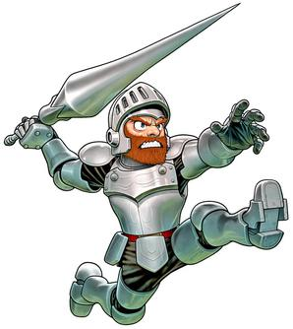**Characters**

**Arthur:** You play as a Knight named Arthur trying to save his princess.

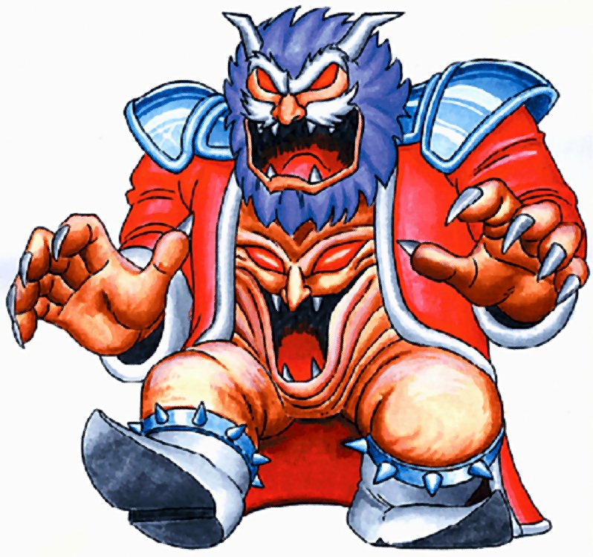

**Astaroth:** Is the Demon King and Arthur’s main antagonist. He has a second form when near death and turns into the undead demon king Nebiroth. Nebiroth is a full separate entity and personality, then Astaroth.

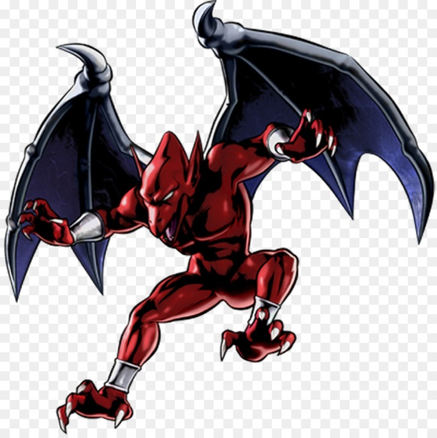**Firebrand:** Belongs to a race of gargoyle demons known as the Red Arremer Tribe, considered the elite warriors of the demon king Astaroth. He is considered a hero among his peers, and as such he has been nicknamed Red Blaze due to his bright red skin and prowess with fiery magic.

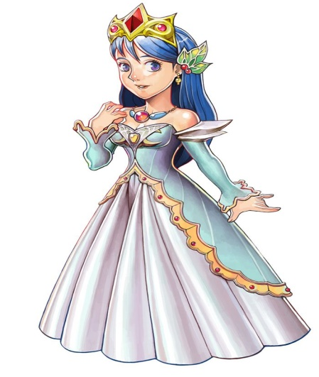**Princess Prin-Prin(Guinevere):** Is the ruler of the human realm—the Kingdom of Hus—and the last human with royal blood. She serves as the primary foil in Ghosts 'n Goblins. Astaroth kidnaps her in order to use her royal blood to invade the human realm.

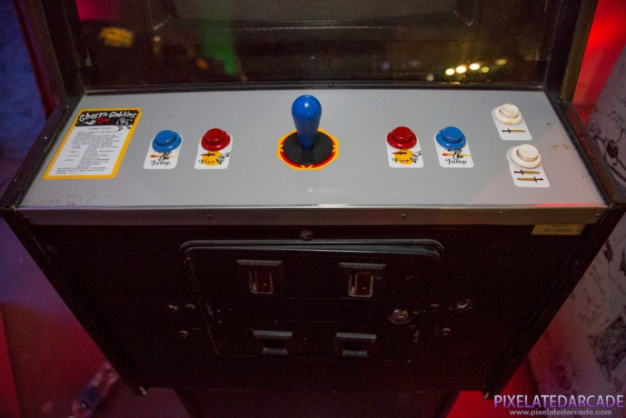**Character Controls**

Single Player Ambidextrous Controls: 8-way Joystick and two buttons Fire and Jump

**Gameplay**

The Game is divided into 6 horizontally or vertically scrolling levels.

Throw lances, axes etc. to kill zombies, bats, demons and other assorted foes. You must defeat the end-of-level boss before you can move on to the next stage.

**Game World**

A map represents the kingdom with various themed levels:

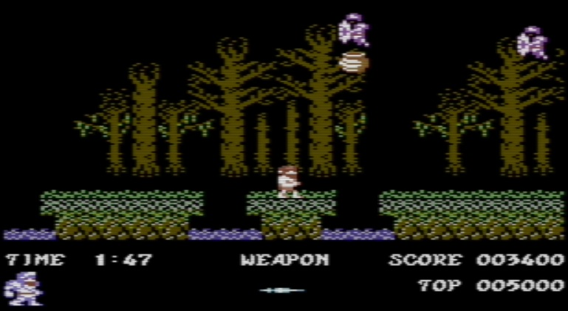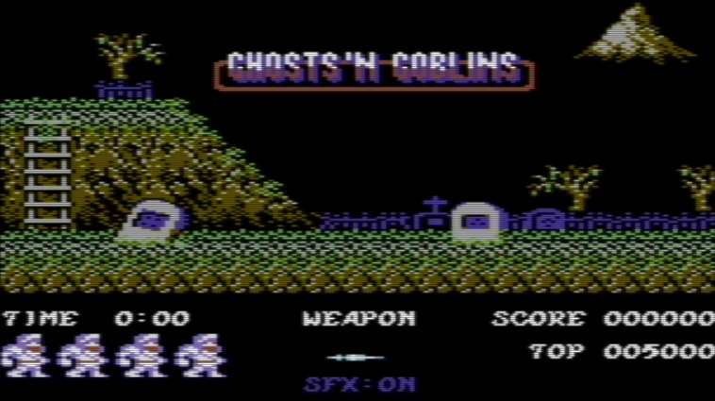**GRAVEYARD and FOREST LEVEL 1**

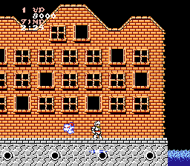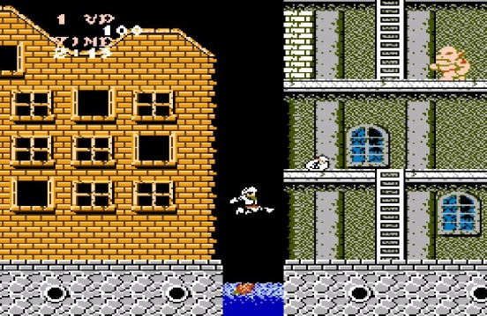**TOWN LEVEL 2**

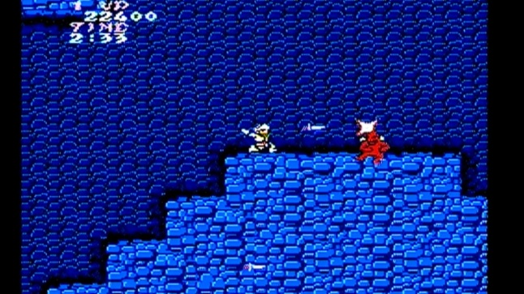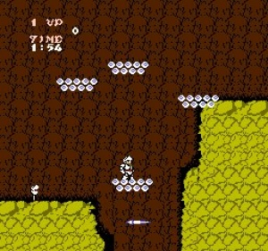**CAVES LEVEL 3**

**BRIDGE LEVEL 4**

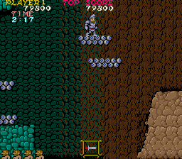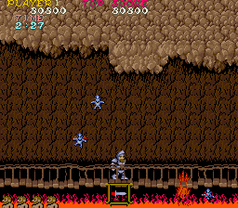

**CASTLE LOWER LEVEL 5**

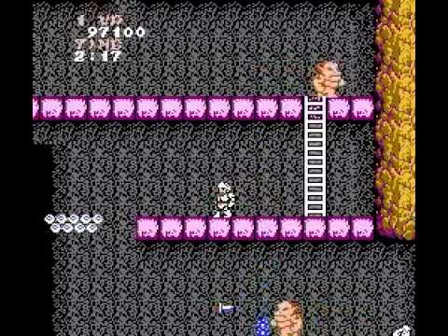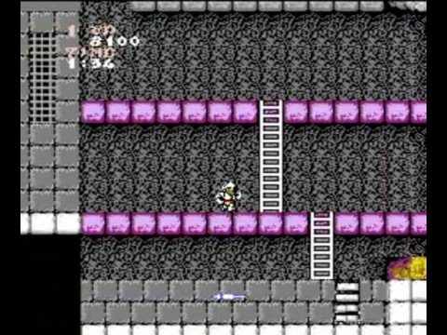

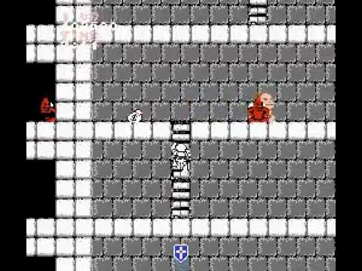**CASTLE UPPER LEVEL 6**

**FINAL BOSS**

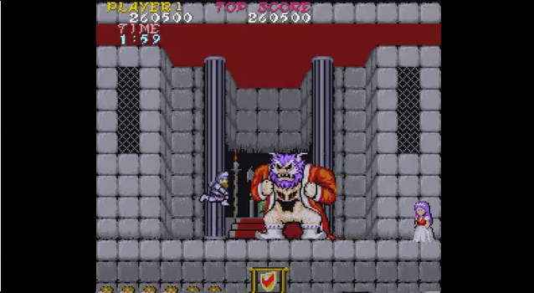

**MUSIC**

Original score and main theme composed by Ayako Mori

The music developed for the first game level is entitled "Graveyard, Forest & Ice Palace”.

**GAME EXPERIENCE**

When you come up to one of the arcade machines this is what you will see first on screen.

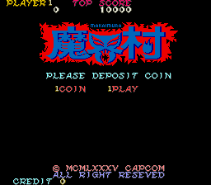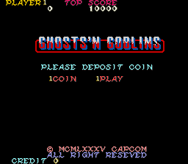North America Japan

Ghosts ’N Goblins give you an adventurous experience fighting evil and trying to rescue the princess. It has an eerie ambience of fighting monsters and the undead.

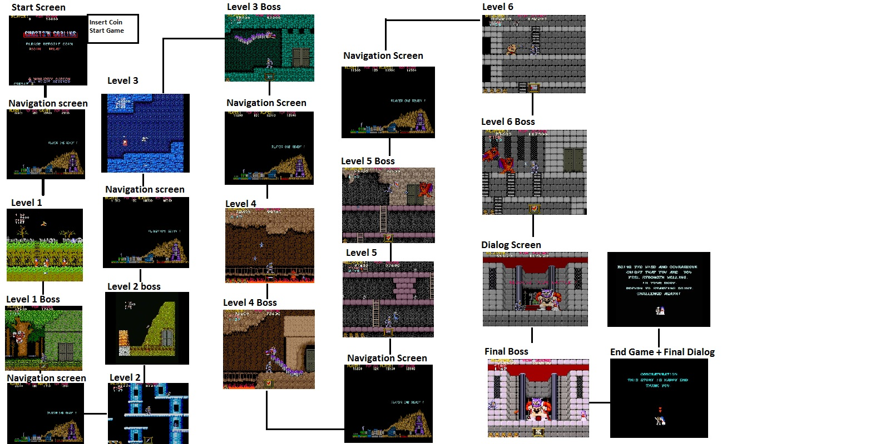**FLOW CHART**

**Game Mechanics**

There are 7 gates in total and to open each gate you must kill each demon at the gate. Once the demon is dead a key will appear from above and fall in front of you. Use the key to open the gates. The last gate you battle the final boss and killing him will allow you to rescue the princess.

You start with a suit of armor when hit once you lose the suit and appear only in your boxers. If you get hit a second time you die. You control Arthur by moving up and down ladders. Jumping over enemies and obstacles like pits and spikes. You can duck and avoid enemies by moving forward or back. You have two button one for attack to throw your weapon or item you have and the second button allows you to jump. If you push the jump button and the attack button you can throw items at your enemies. If you push down and attack you can crouch and throw an item.

There are items throughout the level in jars which you can break open and use. You start off with your javelin but you can acquire 5 different weapons.

Javelins – When thrown can continue off the screen

Torches – When thrown, they form an arc and continue burning. You cannot throw more than 2 at a time until one of the torches burn out.

Sword – Same as Javelin but more speed

Axe – Also from an arc when thrown

Cross – When thrown they fly straight and stop enemies attack.

**ENEMIES and BOSSES**

* Bats - are blue colored and hang on the ceiling until they attack prey that approach them. They move down as Arthur walks near them and they chase after him flying forward with an up and down motion. They appear in Stage 3 and 5
* Big Man - is a large ogre-like enemy. Although Big Men lack armor of any kind, it takes many attacks (10 hits) to pierce their tough tan colored hide. They attack by using their strength to drop heavy objects on their enemies, and when in close combat, they swiftly charge at their foes.
* Flying Knight - is a common enemy in Ghosts 'n Goblins. It is a flying knight. Appearing to be a knight armor possessed by a spirit, these enemies wander through the air, attacking anyone that they encounter
* Green Monster – is a man-eating plant that sprout from corpses and feed upon rotting flesh. Although they lack mobility, they can attack by spitting venomous projectiles from their mouths.
* A Magician - is an enemy that occasionally appears when breaking open a chest. This enemy fires a small round projectile surrounded with very small star-shaped objects in a circular pattern, which can be a major inconvenience when in the middle of battle, as it can temporarily transform the player into a helpless entity such as a baby, old man, village girl or frog, which can get the character killed.
* Raven - is a bird enemy in Ghosts 'n Goblins that attacks by flying in one action. Like the zombies, the energy of the Demon Realm transformed these birds into evil creatures. They are very aggressive, and will attack a person on sight. They appear in two colors:

Blue Ravens attack by flying forward while going up and down.

Red Ravens attack by seeing Arthur from a distance and flying right at him.

* Red Arremer - their great speed and high mobility, easily able to dodge any weapon thrown their way. These demons are very persistent and will stop at nothing to destroy Arthur, spitting small energy balls and diving on him. they appear in stages 1, 3, 4, and 6
* Skeleton - is a common enemy. They first appear to be skulls lying upon the ground. When an enemy approaches, they pull their entire body from the ground and attack by jumping around. They can jump deceivingly high.
* Tower Monster - is a living rock creature that attacks by spitting projectile at Arthur.
* Woody Pig - is a pig spirit with a large pig nose, its nostrils resembling eyes, that wears a stump. These spirits of the woods appear abruptly in the Ghosts 'n Goblins stages 1, 3, 5, and 6, and fly through the air.
* Zombies - are enemies that basically will come up from the ground and walk towards Arthur. These are corpses that have been revived by the energy of the Demon Realm. These hordes of living dead have no will of their own, and attack people in order to preserve their rotting flesh.
* Unicorn – Boss - is a large, grey humanoid monster with a single horn and eye. Having twice the size of Arthur, it has massive strength. It has incredible jumping power, rising high into the air to land on and squash its opponents. Requires 10 hits to be defeated.
* Dragon - Boss -It flies around the area from one side to the other. If someone invades the Dragon's lair, it aggressively attacks until the enemy is pulverized. It staggers enemies with its long body and spews fire from its gigantic mouth.
* Satan – Boss - is the red beast that captures Princess Prin Prin in the beginning of Ghosts 'n Goblins. He is a strong opponent who uses his swooping attack while hurling star projectiles. Arthur faces him in stages 5 and 6. Like Astaroth, he is able to create identical clones of himself that are controlled by his own soul (which explains how Arthur fights two Satan’s simultaneously during stage 6). He is also responsible for creating the illusion and trap that forces Arthur to pass by all stages twice.
* The Great Demon Lord Astaroth – Boss - is the ruler of the Demon Realm Village. He is the main antagonist of Knight Arthur, being the final boss. He is apparently based on Astaroth (also Ashtaroth, Astarot and Asteroth), a Crowned Prince of Hell in demonology.

**Monetization**

For being an Arcade/Coin operated machine, this game will be worth every coin you throw into it. It’s a highly entertaining game that will keep you occupied for hours.

